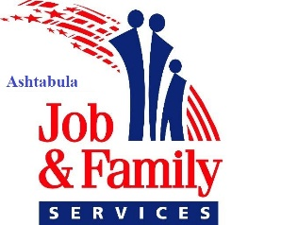

Access Our Services
FROM HOME

Access Our Website at acdjfs.org
This is the easiest way to find out information for Child Support, Public Assistance, Workforce, and Protective Service programs.
Drop Off Documents
Documents for all programs can be placed in agency drop boxes, which are located in the lobbies at both locations.
Child Support
CSEA clients can contact workers and see account info at http://jfs.ohio.gov/ocs
Clients can submit payments at Ohio CSPC, PO Box 182372, Columbus, OH 43218 or at https://oh.smartchildsupport.com or placed in the lobby drop box.
CSEA can be reached at 440-994-1212 or 1-800-935-0242
Public Assistance Programs
www.benefits.ohio.gov
The above link allows you to apply, renew, or make changes for cash, food or medical assistance. You can also call 1-844-640-64476 to apply, renew, or make changes for medical assistance. Documents can be dropped off, uploaded to your Ohio Benefits account, or emailed to: Ashtabula-Verifications@jfs.ohio.gov. For case questions, please call 440-998-1110.
Adult Protective Services
Adult Protective Services staff will remain accessible during normal business hours, Monday-Friday, 8:00 a.m. to 4:30 p.m. and will continue to provide emergent coverage. Phone 440-997-7777 to report abuse, neglect or exploitation of senior citizens.
Workforce and OhioMeansJobs Services
If you have internet access, you can utilize ohiomeansjobs.com
If you have any questions, please call 440-994-1234 from 8 a.m. to 4:30 p.m.

*If you have questions regarding any of the above information, please call 440-998-1110.

